SOLUTION REQUIREMENT
3.1 Solution Requirements (Functional & Non-functional)
Date | 7th February 2026
Team ID | LTVIP2026TMIDS84448
Project Name | Civil Engineering Insight Studio
Maximum Marks | 4 Marks
3.1.1 Functional Requirements:
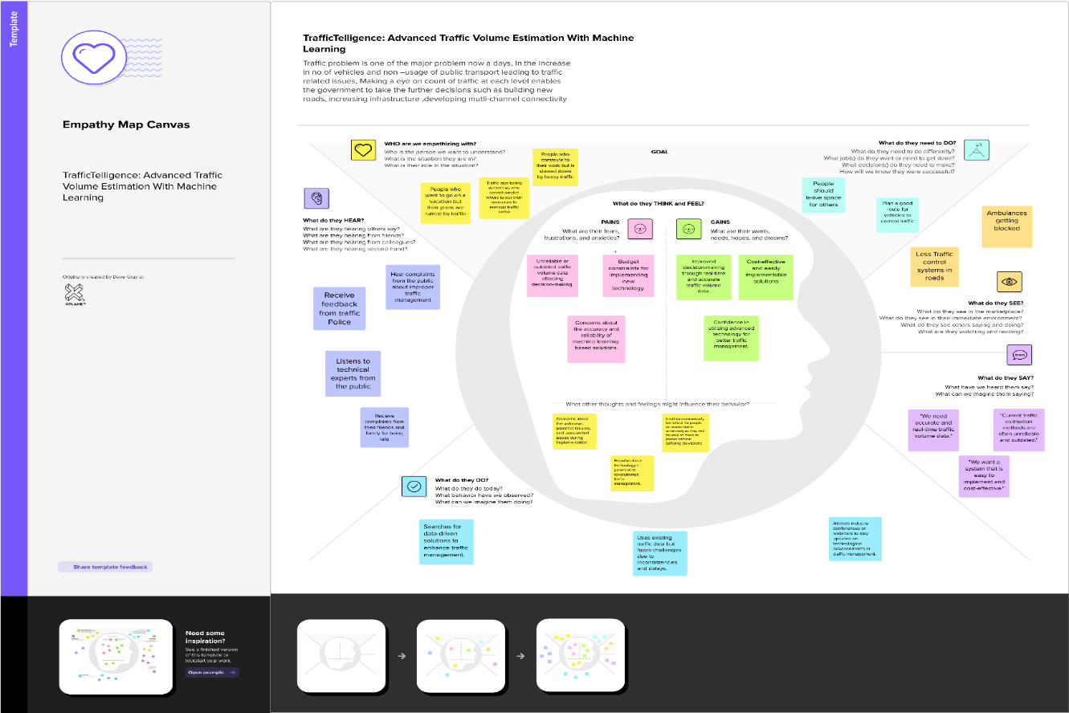
Following are the functional requirements of the proposed solution.

FR No. | Functional Requirement (Epic) | Sub Requirement (Story / Sub-Task)
FR-1 | Data Preprocessing & Validation | Convert raw project and design data into a clean and structured format Validate engineering inputs and remove inconsistencies
FR-2 | Structural Analysis & Classification | Analyze structural elements using engineering models  Classify components such as beams, columns, slabs, and foundations
FR-3 | Performance Analysis & Reporting | Evaluate structural performance and safety factors  Generate project-wise, daily, or phase-wise analytical reports
FR-4 | Insight Generation & Reporting | Estimate cost, safety, and sustainability metrics  Generate visual and tabular reports
3.1.2 Non-functional Requirements:
Following are the non-functional requirements of the proposed solution.
FR No. | Non-Functional Requirement | Description
NFR-1 | Usability | The system should provide an intuitive and user-friendly interface that allows civil engineers and planners to easily input data and interpret analytical results.
NFR-2 | Security | Data collected from surveillance should be securely stored and transmitted using encryption.
NFR-3 | Reliability | The system should maintain consistent accuracy in vehicle detection and count under various lighting and weather conditions.
NFR-4 | Performance | The ML model should process traffic data in near real-time with minimal latency.
NFR-5 | Availability | The system should be accessible 24/7 with minimum downtime, especially during peak traffic hours.

